**Push Notification with React js**

**Creating Firebase Google messaging account:**

* Step 1: Open firebase profile and click on get started:

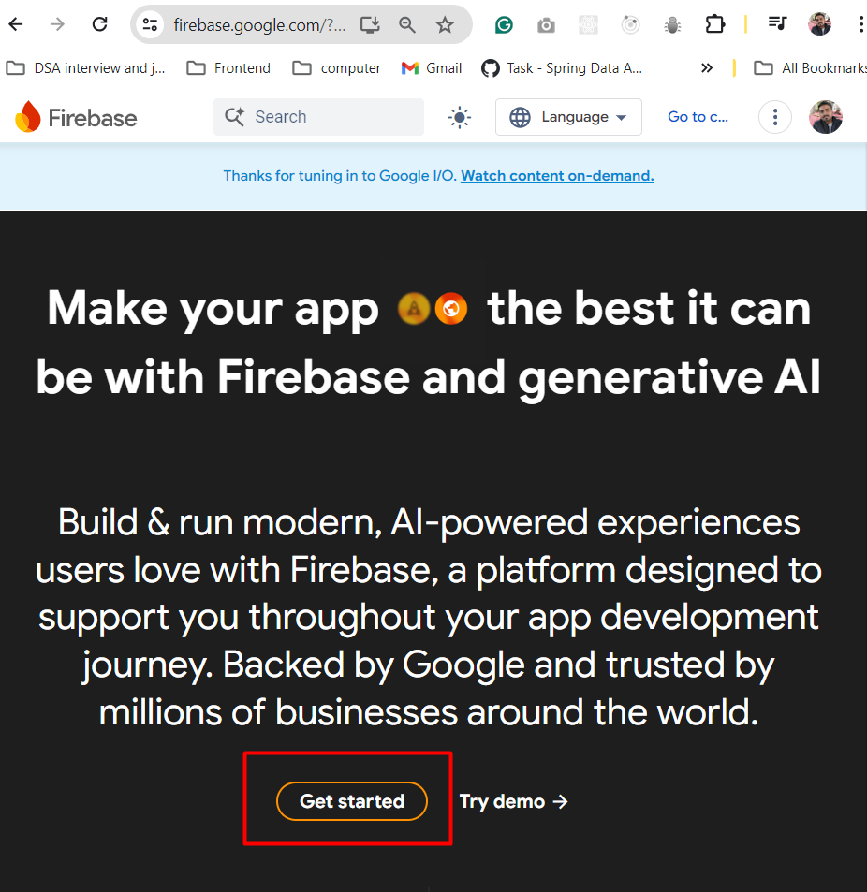

* Step 2: Click on Get started with a firebase project and create new project

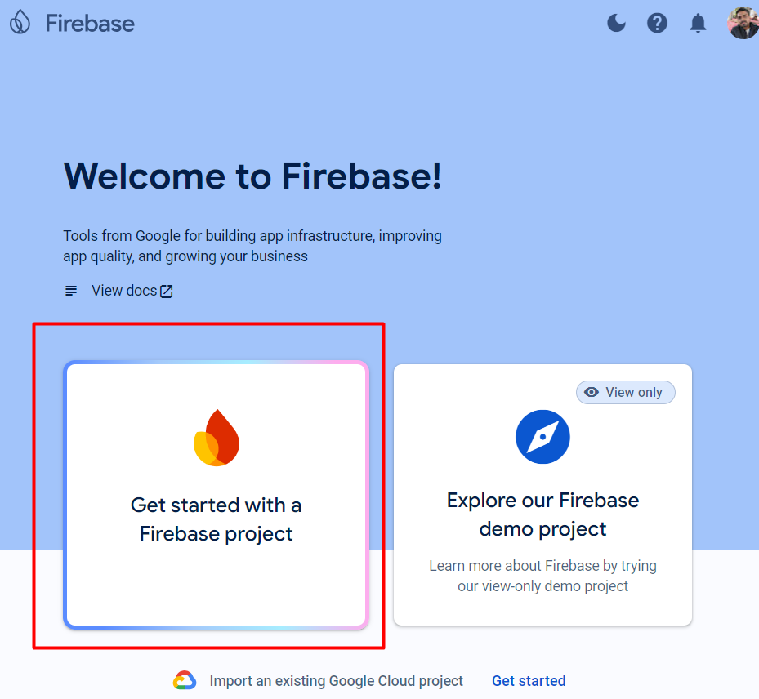

* Step 3: Enter project name

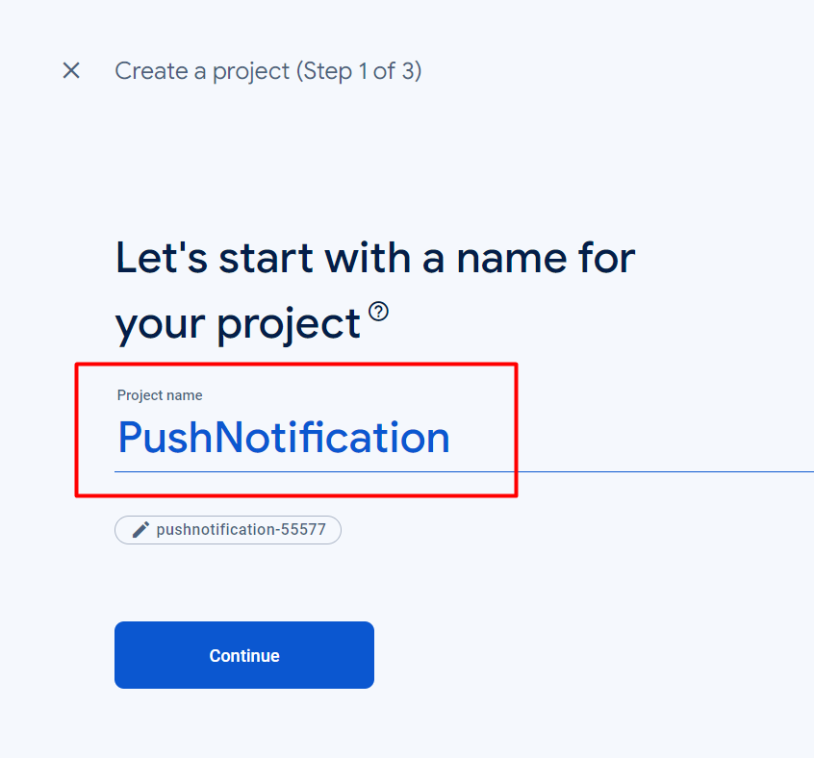

* Step 4: Disabled google analytics

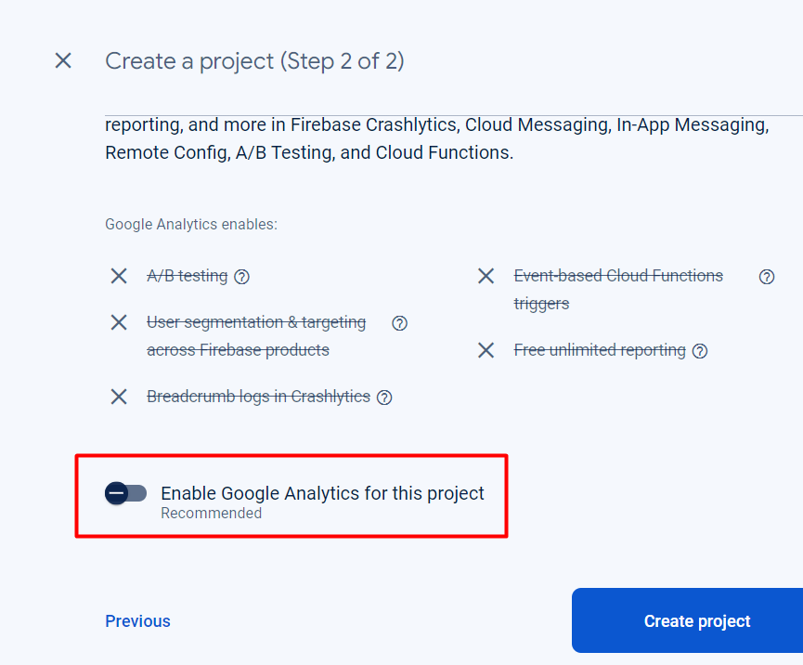

* Project is created:

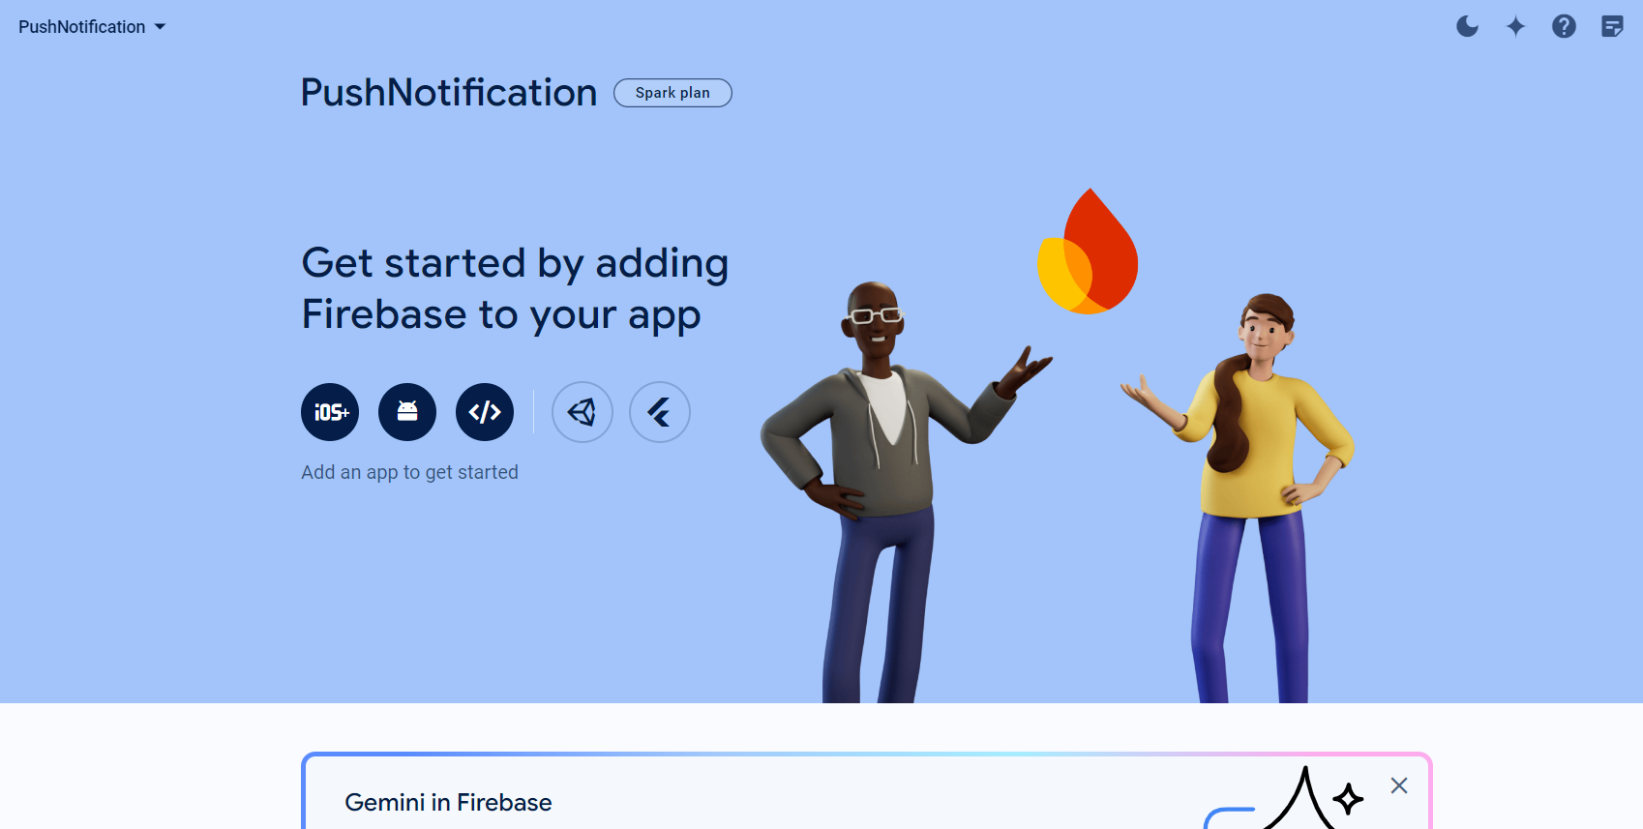

* Now scroll down and click on cloud messaging:

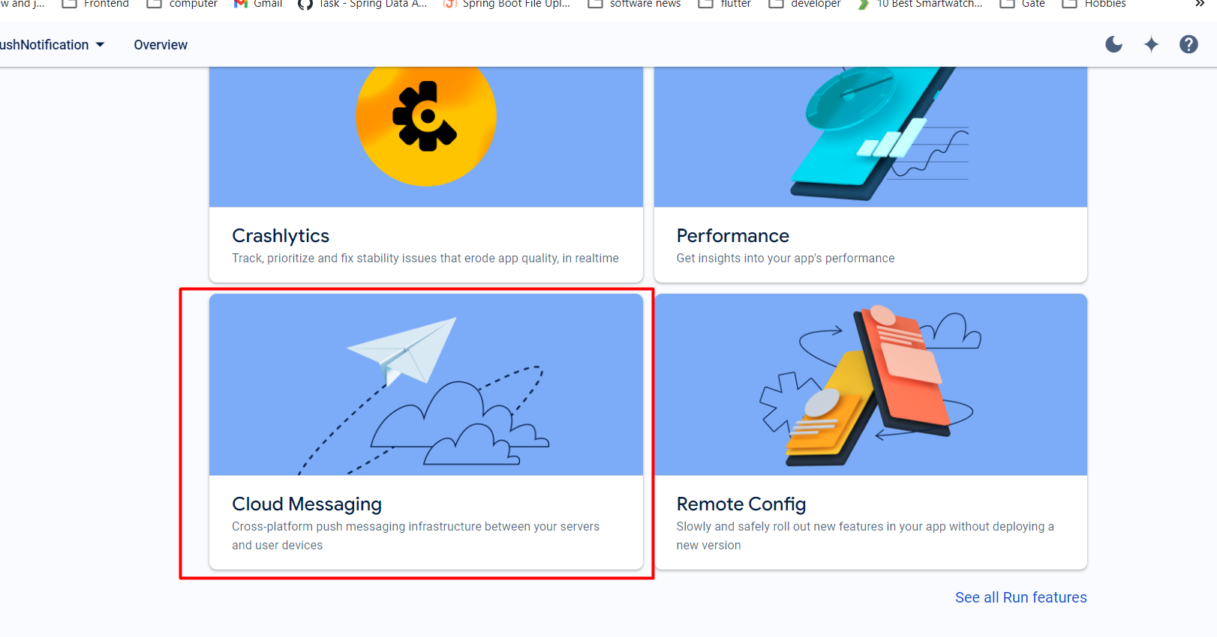

* Click on the web app logo:

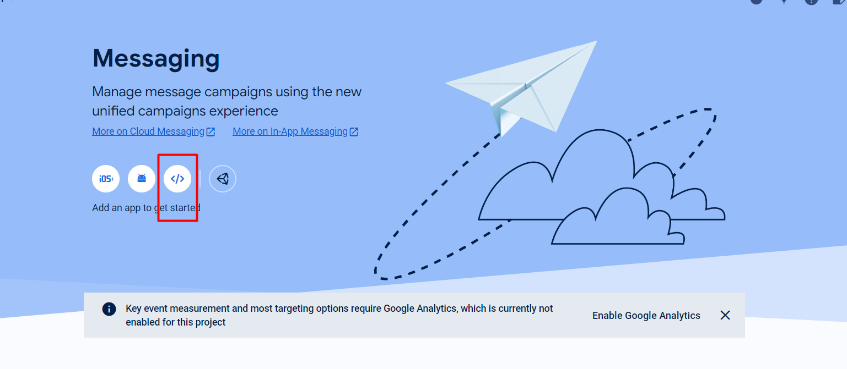

* Name the app and click on register app

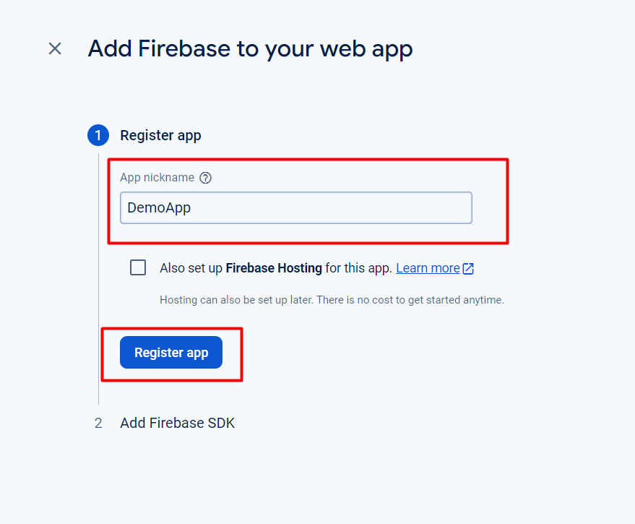

* Now the screen will display the integration we need to do in react app  
  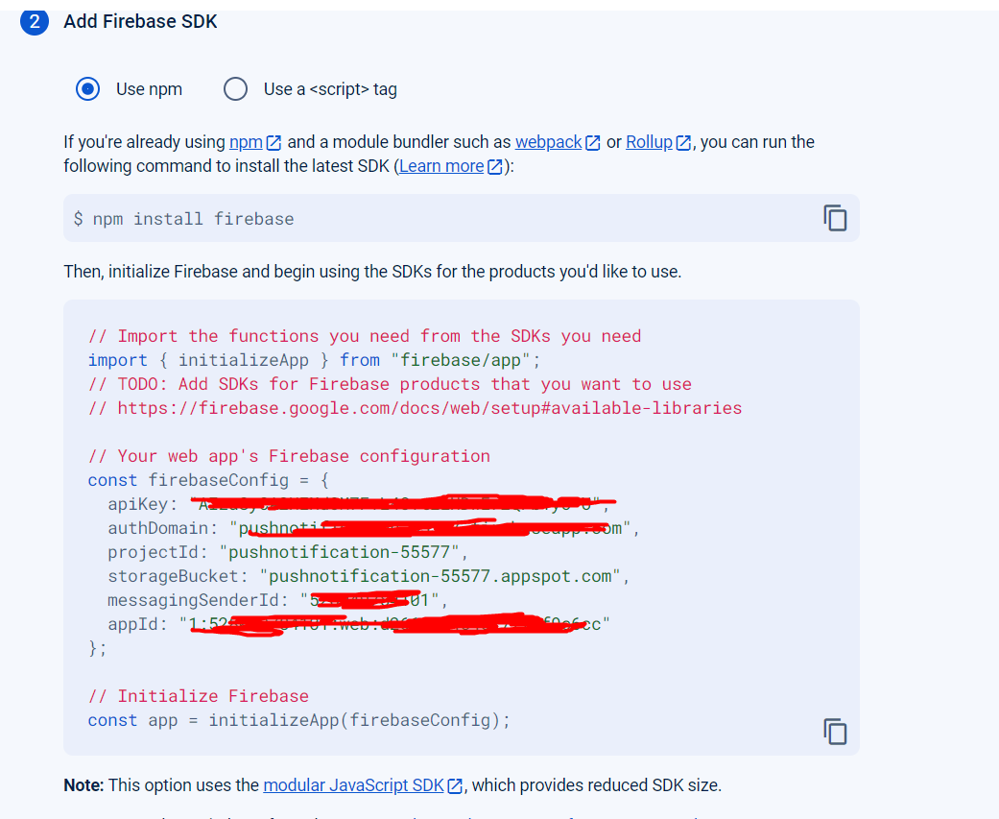  
  After that click on finish and go to the console
* Then, open the google docs for the build and go to the cloud messaging section:  
  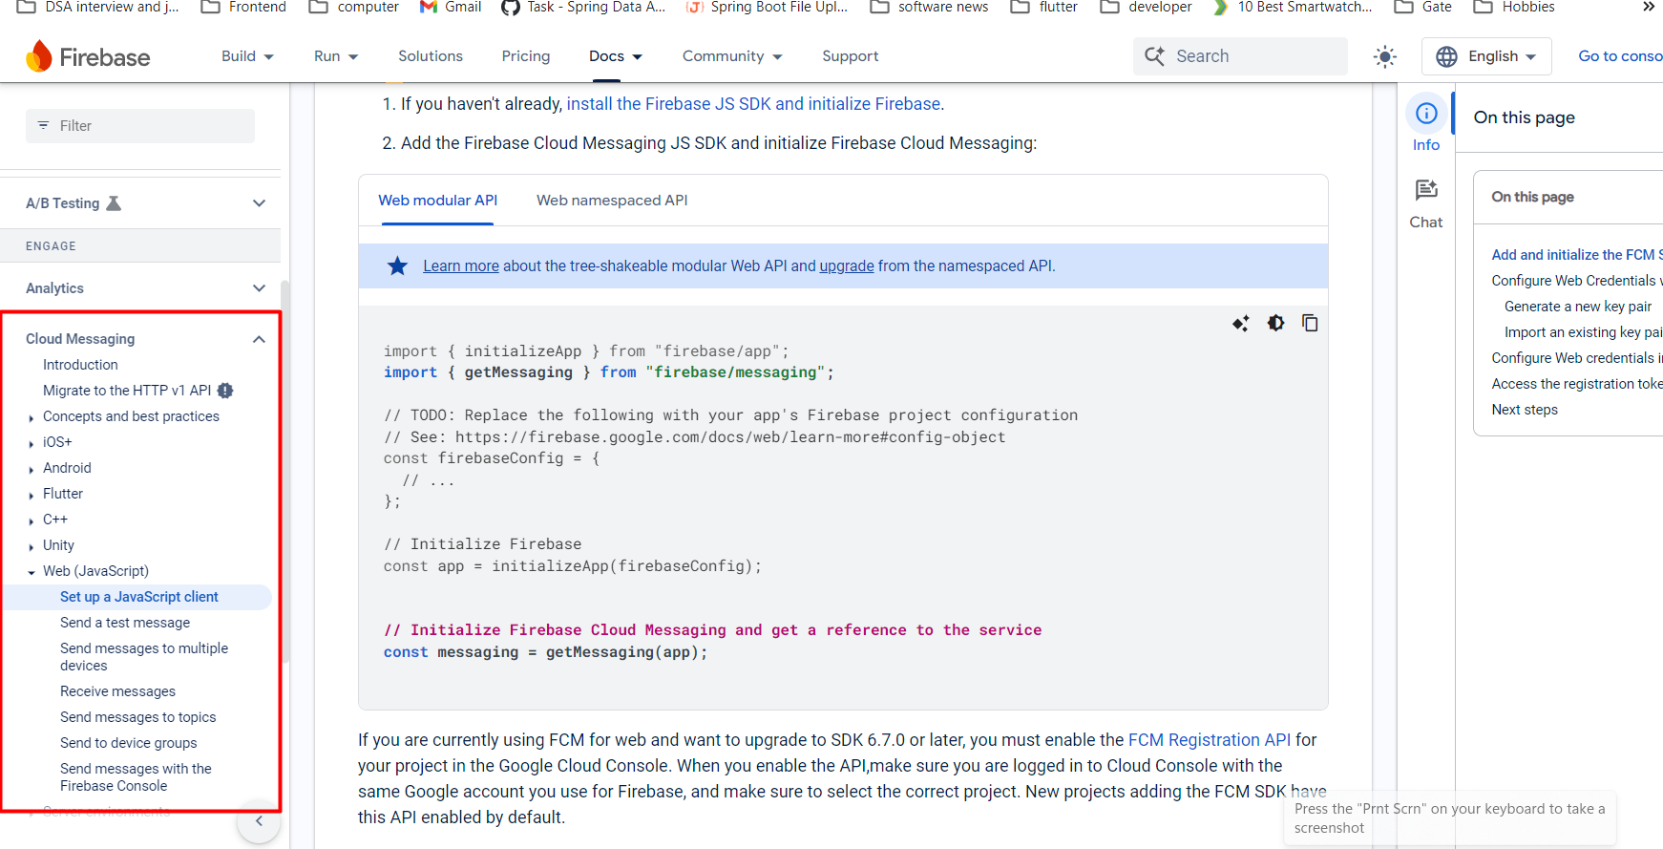  
  getMessaging thing we need to add in the code
* Then we need to go to Project settings of our created project  
  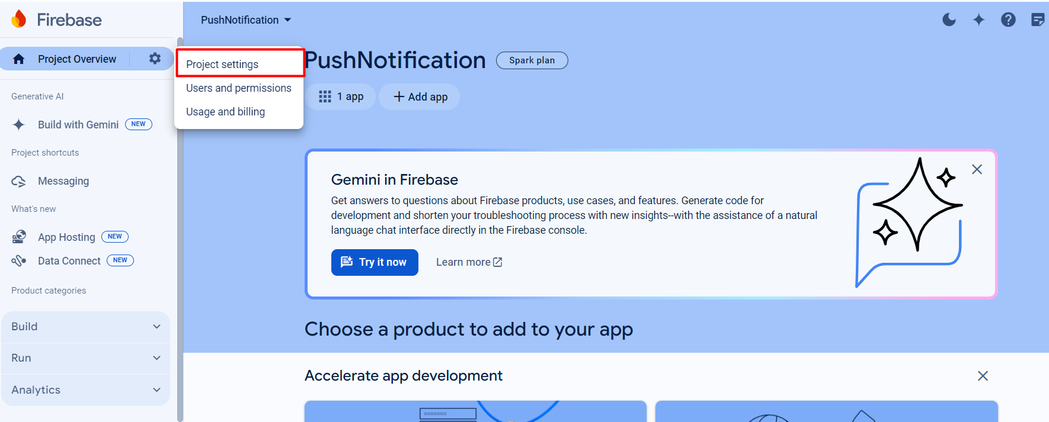
* Go to cloud messaging and click on generate key pair  
  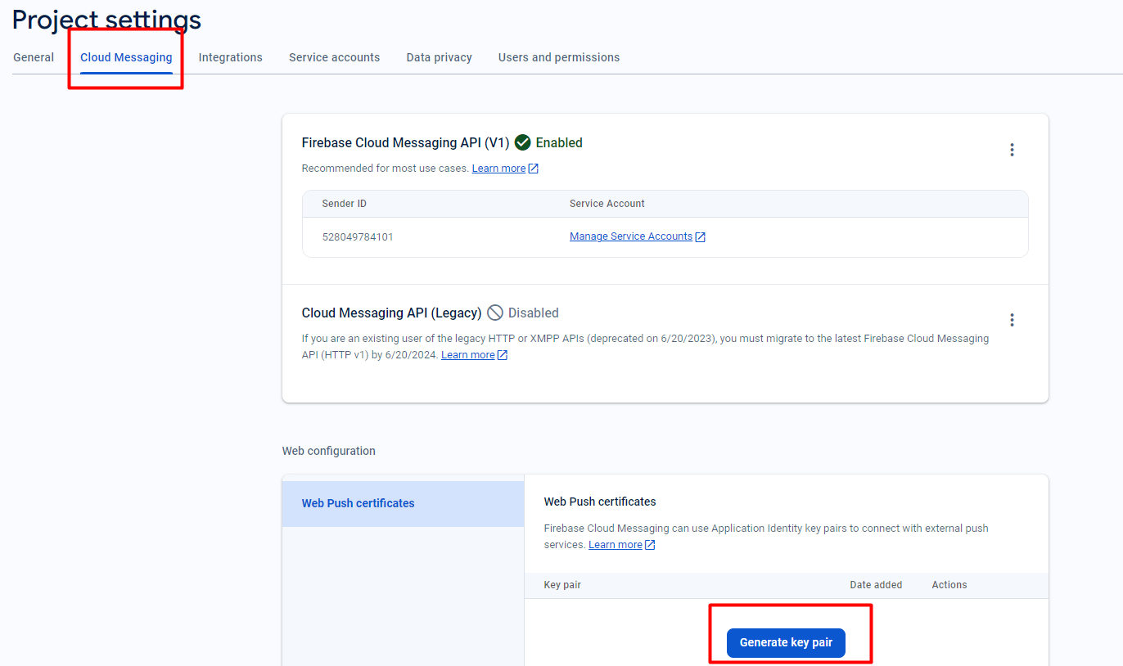  
  The key which is generated is called ‘vapid’ key and it will be used to generate the unique token.
* After making the function to generate token in the react app and giving the ‘vapid key’ to the react project, we need to work on receive messages from the doc  
  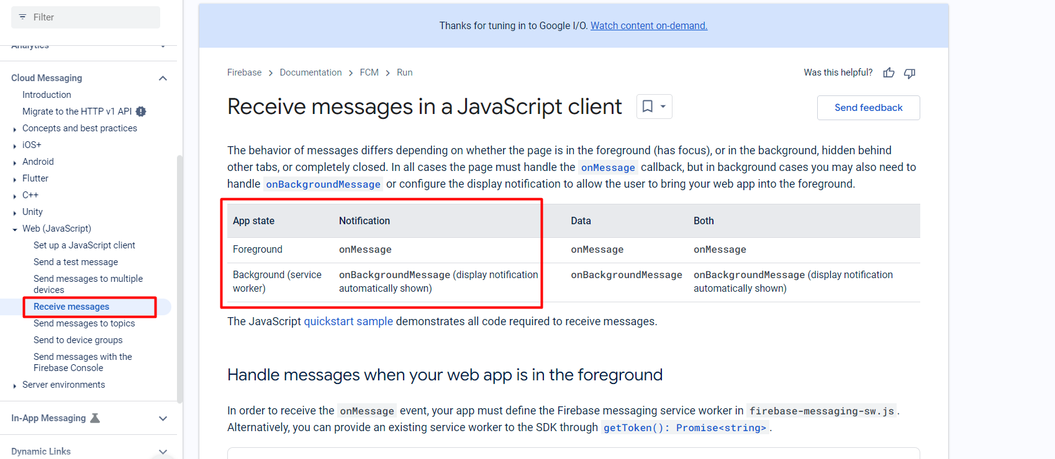
  + Foreground means the app will be active then the notification will be handled by the app
  + Background messaging will be handled by the service worker.
* Next step is to integrate following in our code:  
  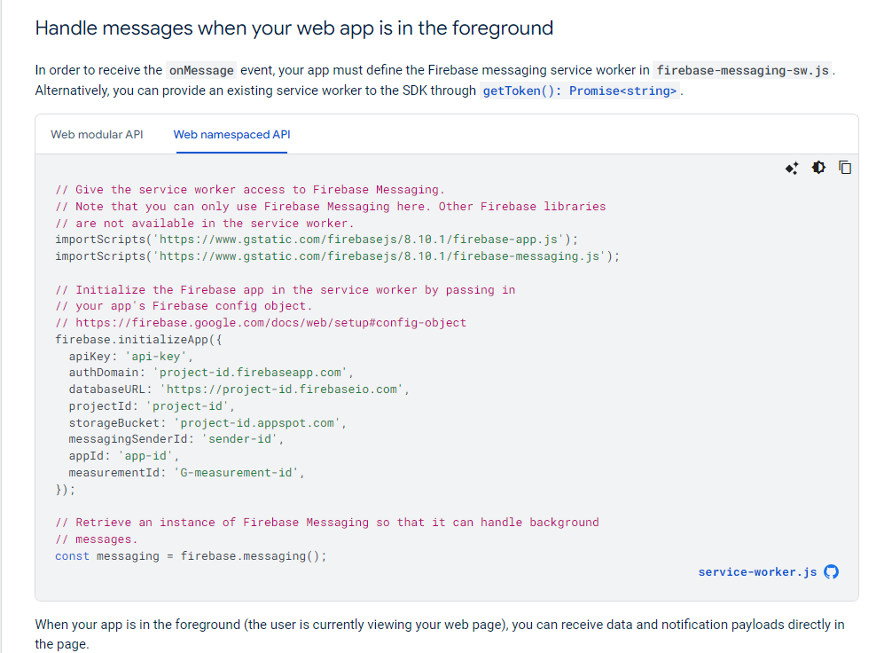
* Then in the same file as above we need to add:  
  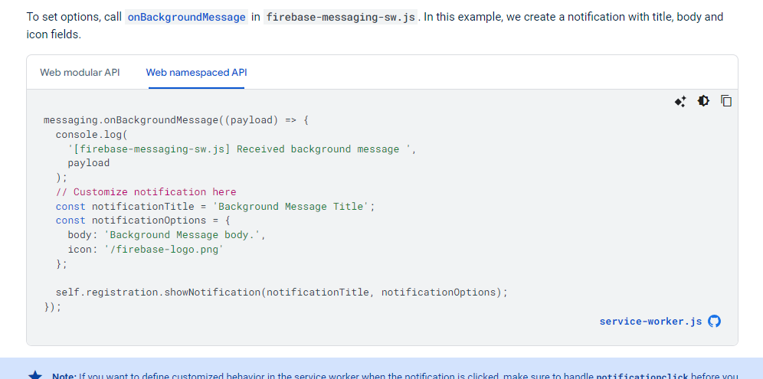
* After creating everything, go to our project, click messaging from sidebar and click on “Create our first campaign”  
  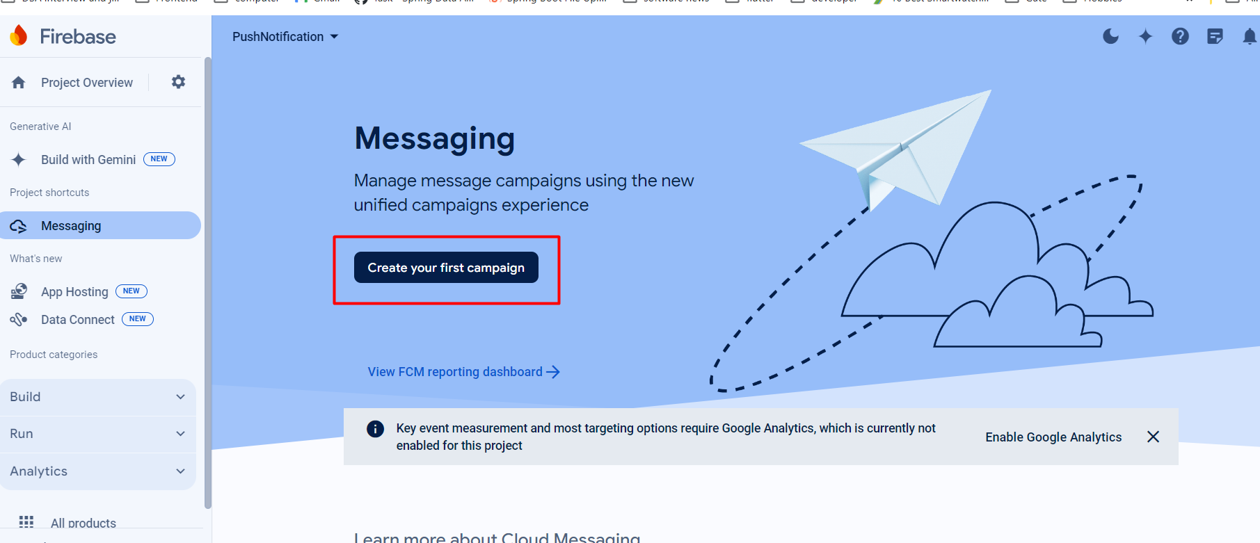
* next step  
  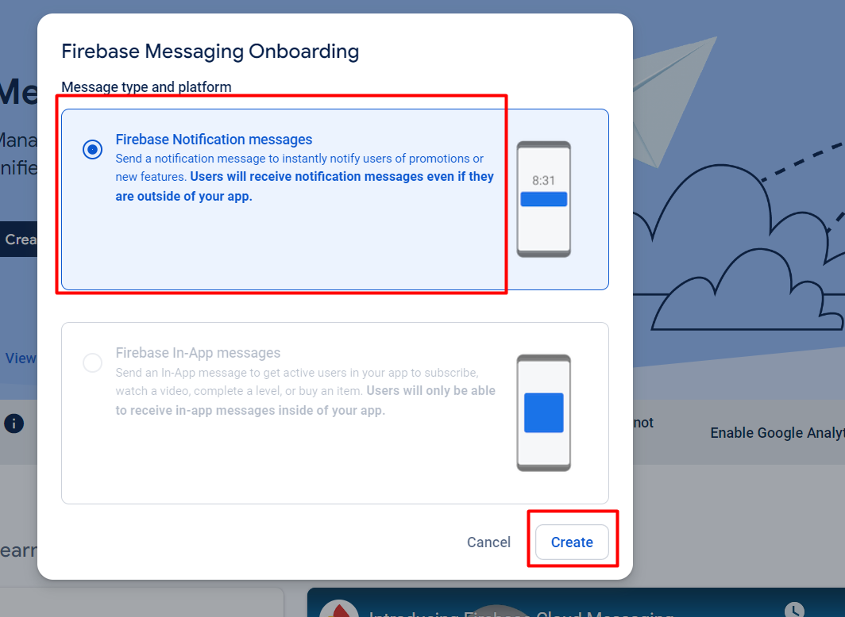
* Then write the msg and icon to send and send a test message:  
  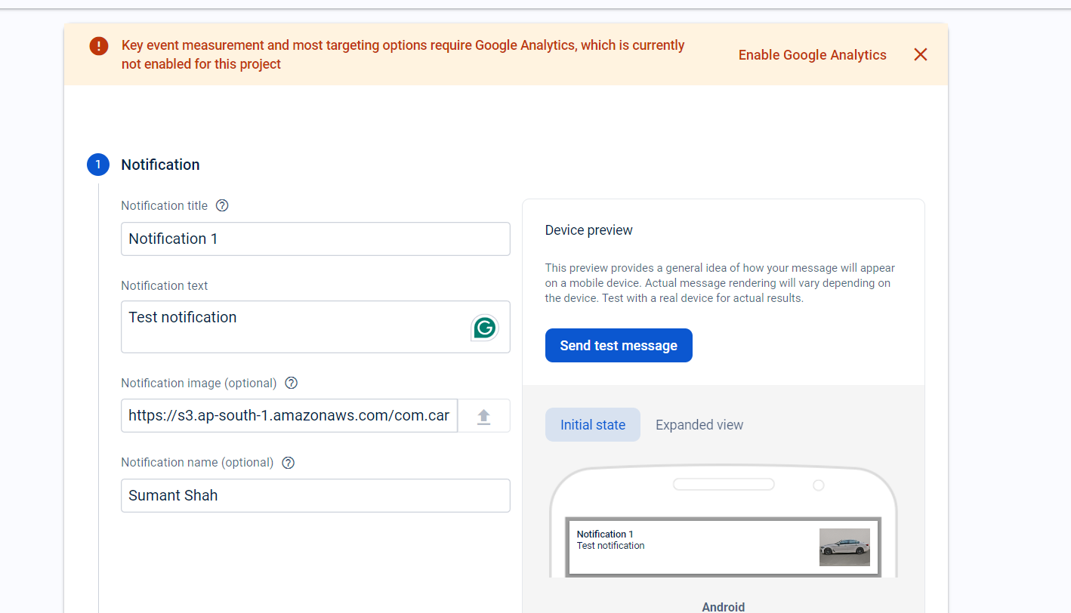
  + You need to add the registration token:  
    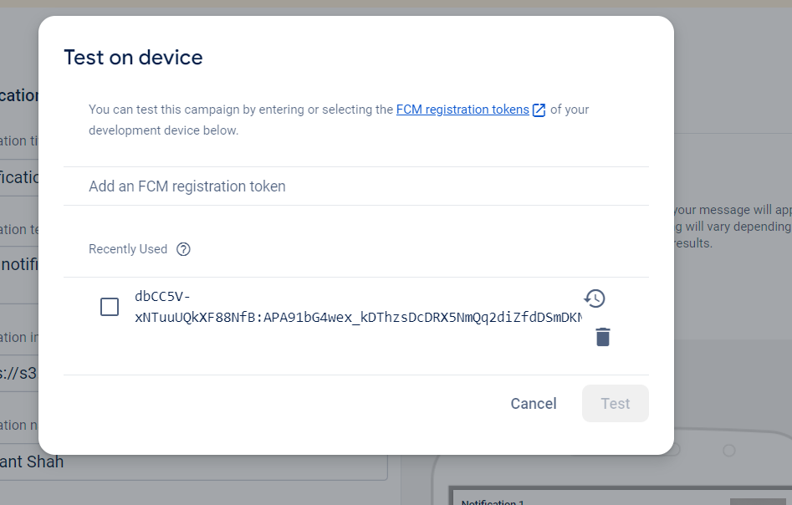
  + sample notification: 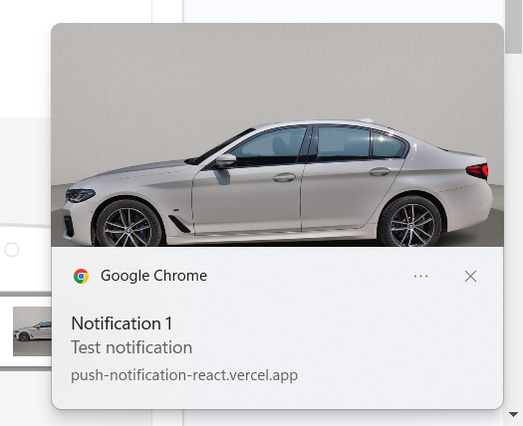
* Next step:  
  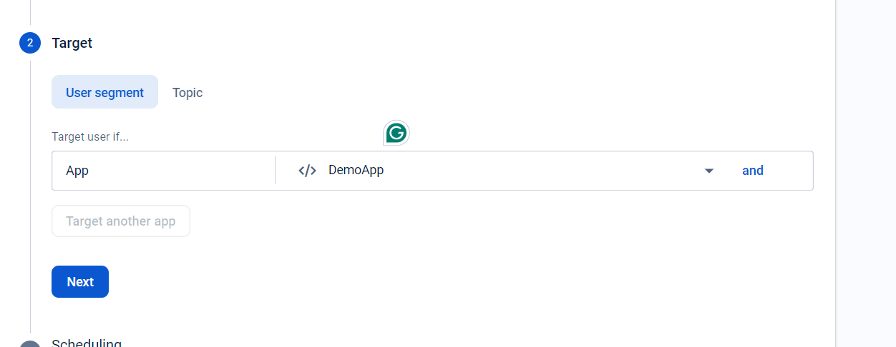
* next step:  
  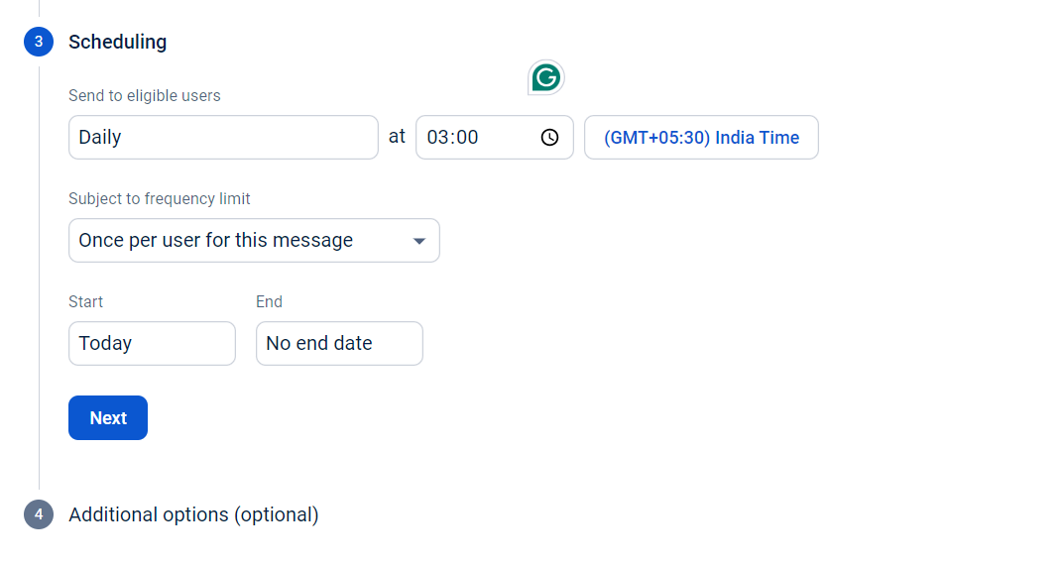
* Backend trigger with the device token:  
  